|  |
| --- |
| Circle Language Spec: Interfaces |

## Interface Referencing and Redirectioning

This article contains examples of what diferent interface referencing and redirectioning situations would look like in a diagram and what name we could give to this situation.

#### Interface Reference

An object’s specification of which interface it has, is also called an *interface reference*.

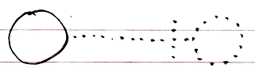

#### Command Class Interface

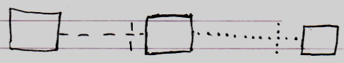

#### Class Command Interface

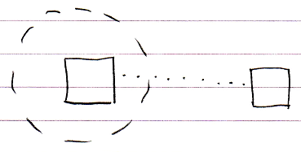

#### Command Definition Interface Redirection

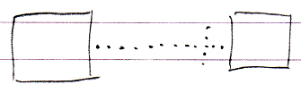

#### Command Reference Interface Redirection

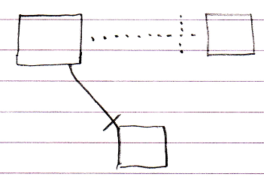

#### Command Call Interface Redirection

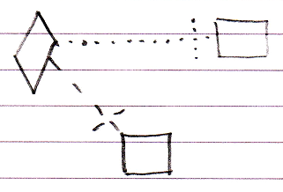

#### Active Clause Interface Redirection

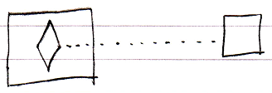

#### Inactive Clause Interface Redirection

